
VISUAL PROGRAMMING
Weekly Task


Name: WASIF ALI
Reg Id: 245187
Course: Visual Programming
Instructor: SIR GHULAM
Date: 10/05/2025
VP BLOCKLY ASSIGNMENT
Random Number Guessing Game
🔹 Tool Used: Google Blockly (https://developers.google.com/blockly)
1. Objective
To create a simple interactive game where the computer randomly selects a number, and the player guesses it. The program gives hints whether the guess is too high or too low until the correct number is guessed.
2. Idea Description
The game generates a random number between 1 and 10.
The user inputs a number as their guess.
- If the guess is correct, the game displays “🎉 You guessed it right!”
- If the guess is too high, it displays “Try a smaller number!”
- If the guess is too low, it displays “Try a bigger number!”
- After each guess, the program also shows the attempt number to keep track of how many tries the player made.
- If the player fails to guess the number within 5 attempts, the game displays a “😢 Game Over! You ran out of tries!” message and ends the game.
The player continues guessing until they find the correct number or the Game Over condition occurs.
3. Working Principle
- Uses variables to store the random number, user input, and number of attempts.
- Uses “if–else” blocks to check whether the guess is correct, too high, or too low.
- Uses a loop (repeat until) to keep asking for guesses until the correct number is guessed.
- Uses logic blocks to check when attempts exceed the limit and show the “Game Over” message.
- Uses text blocks to display messages, attempt counters, and feedback to the user.
4. Blockly Blocks Used
- Variables → set, change, attempts counter
- Math → random integer from 1 to 10
- Logic → if / else if / else, greater than (>) for attempt limit
- Loops → repeat until
- Text → join, print, prompt (ask for input)
5. Screenshots (Output):
- The main Blockly workspace (showing all connected blocks).
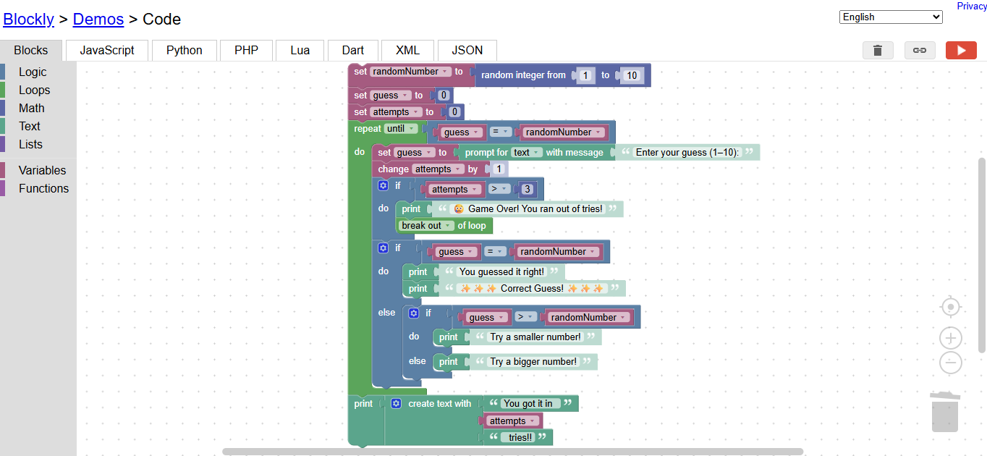
- The variable setup part (random number creation).
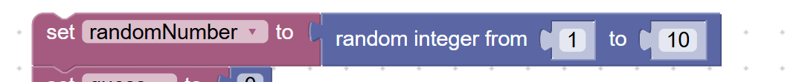
- The loop and “if-else” condition part with the Game Over logic.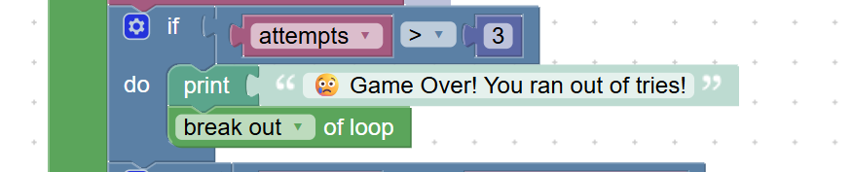

- The output or execution window (showing user interaction).
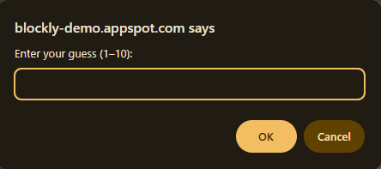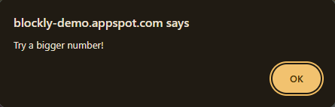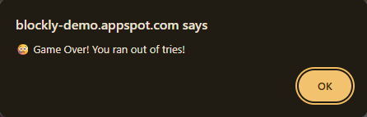
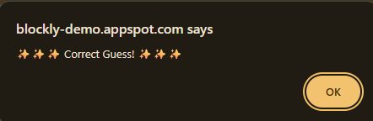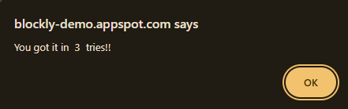
6. Short Explanation
I made a Random Number Guessing Game using Blockly. The program generates a random number from 1 to 10 and asks the user to guess it. It checks if the guess is correct, too high, or too low, and gives feedback accordingly. I also added a counter to display how many attempts were made and included a ‘Game Over’ condition if the player fails after 5 tries. The game continues until the correct number is guessed or the attempt limit is reached. I used logic, loops, and random number blocks to make it interactive, fun, and unique.
7. Features & Uniqueness
- Interactive guessing logic
- Dynamic feedback with emojis for engagement
- Randomized number every time
- Game Over feature after 5 attempts
- Attempt counter displayed after each guess
- Clear, event-driven logic using Blockly’s visual programming
- Can easily add sound or animation blocks in future versions

8. Evaluation Checklist
Criteria | Marks | Achieved
Working Project | 2 | ✅
Creativity | 1 | ✅
Clear Use of Blocks | 2 | ✅
Uniqueness (extra feature) | 2 | ✅
Explanation | 3 | ✅

9. Conclusion
This project helped me understand how logical flow, conditions, and loops work in visual programming using Blockly. The Random Number Guessing Game was simple yet interactive, and adding features like attempt tracking and a Game Over condition made it more engaging. This activity improved my understanding of event-driven programming and problem-solving in a fun and creative way.

